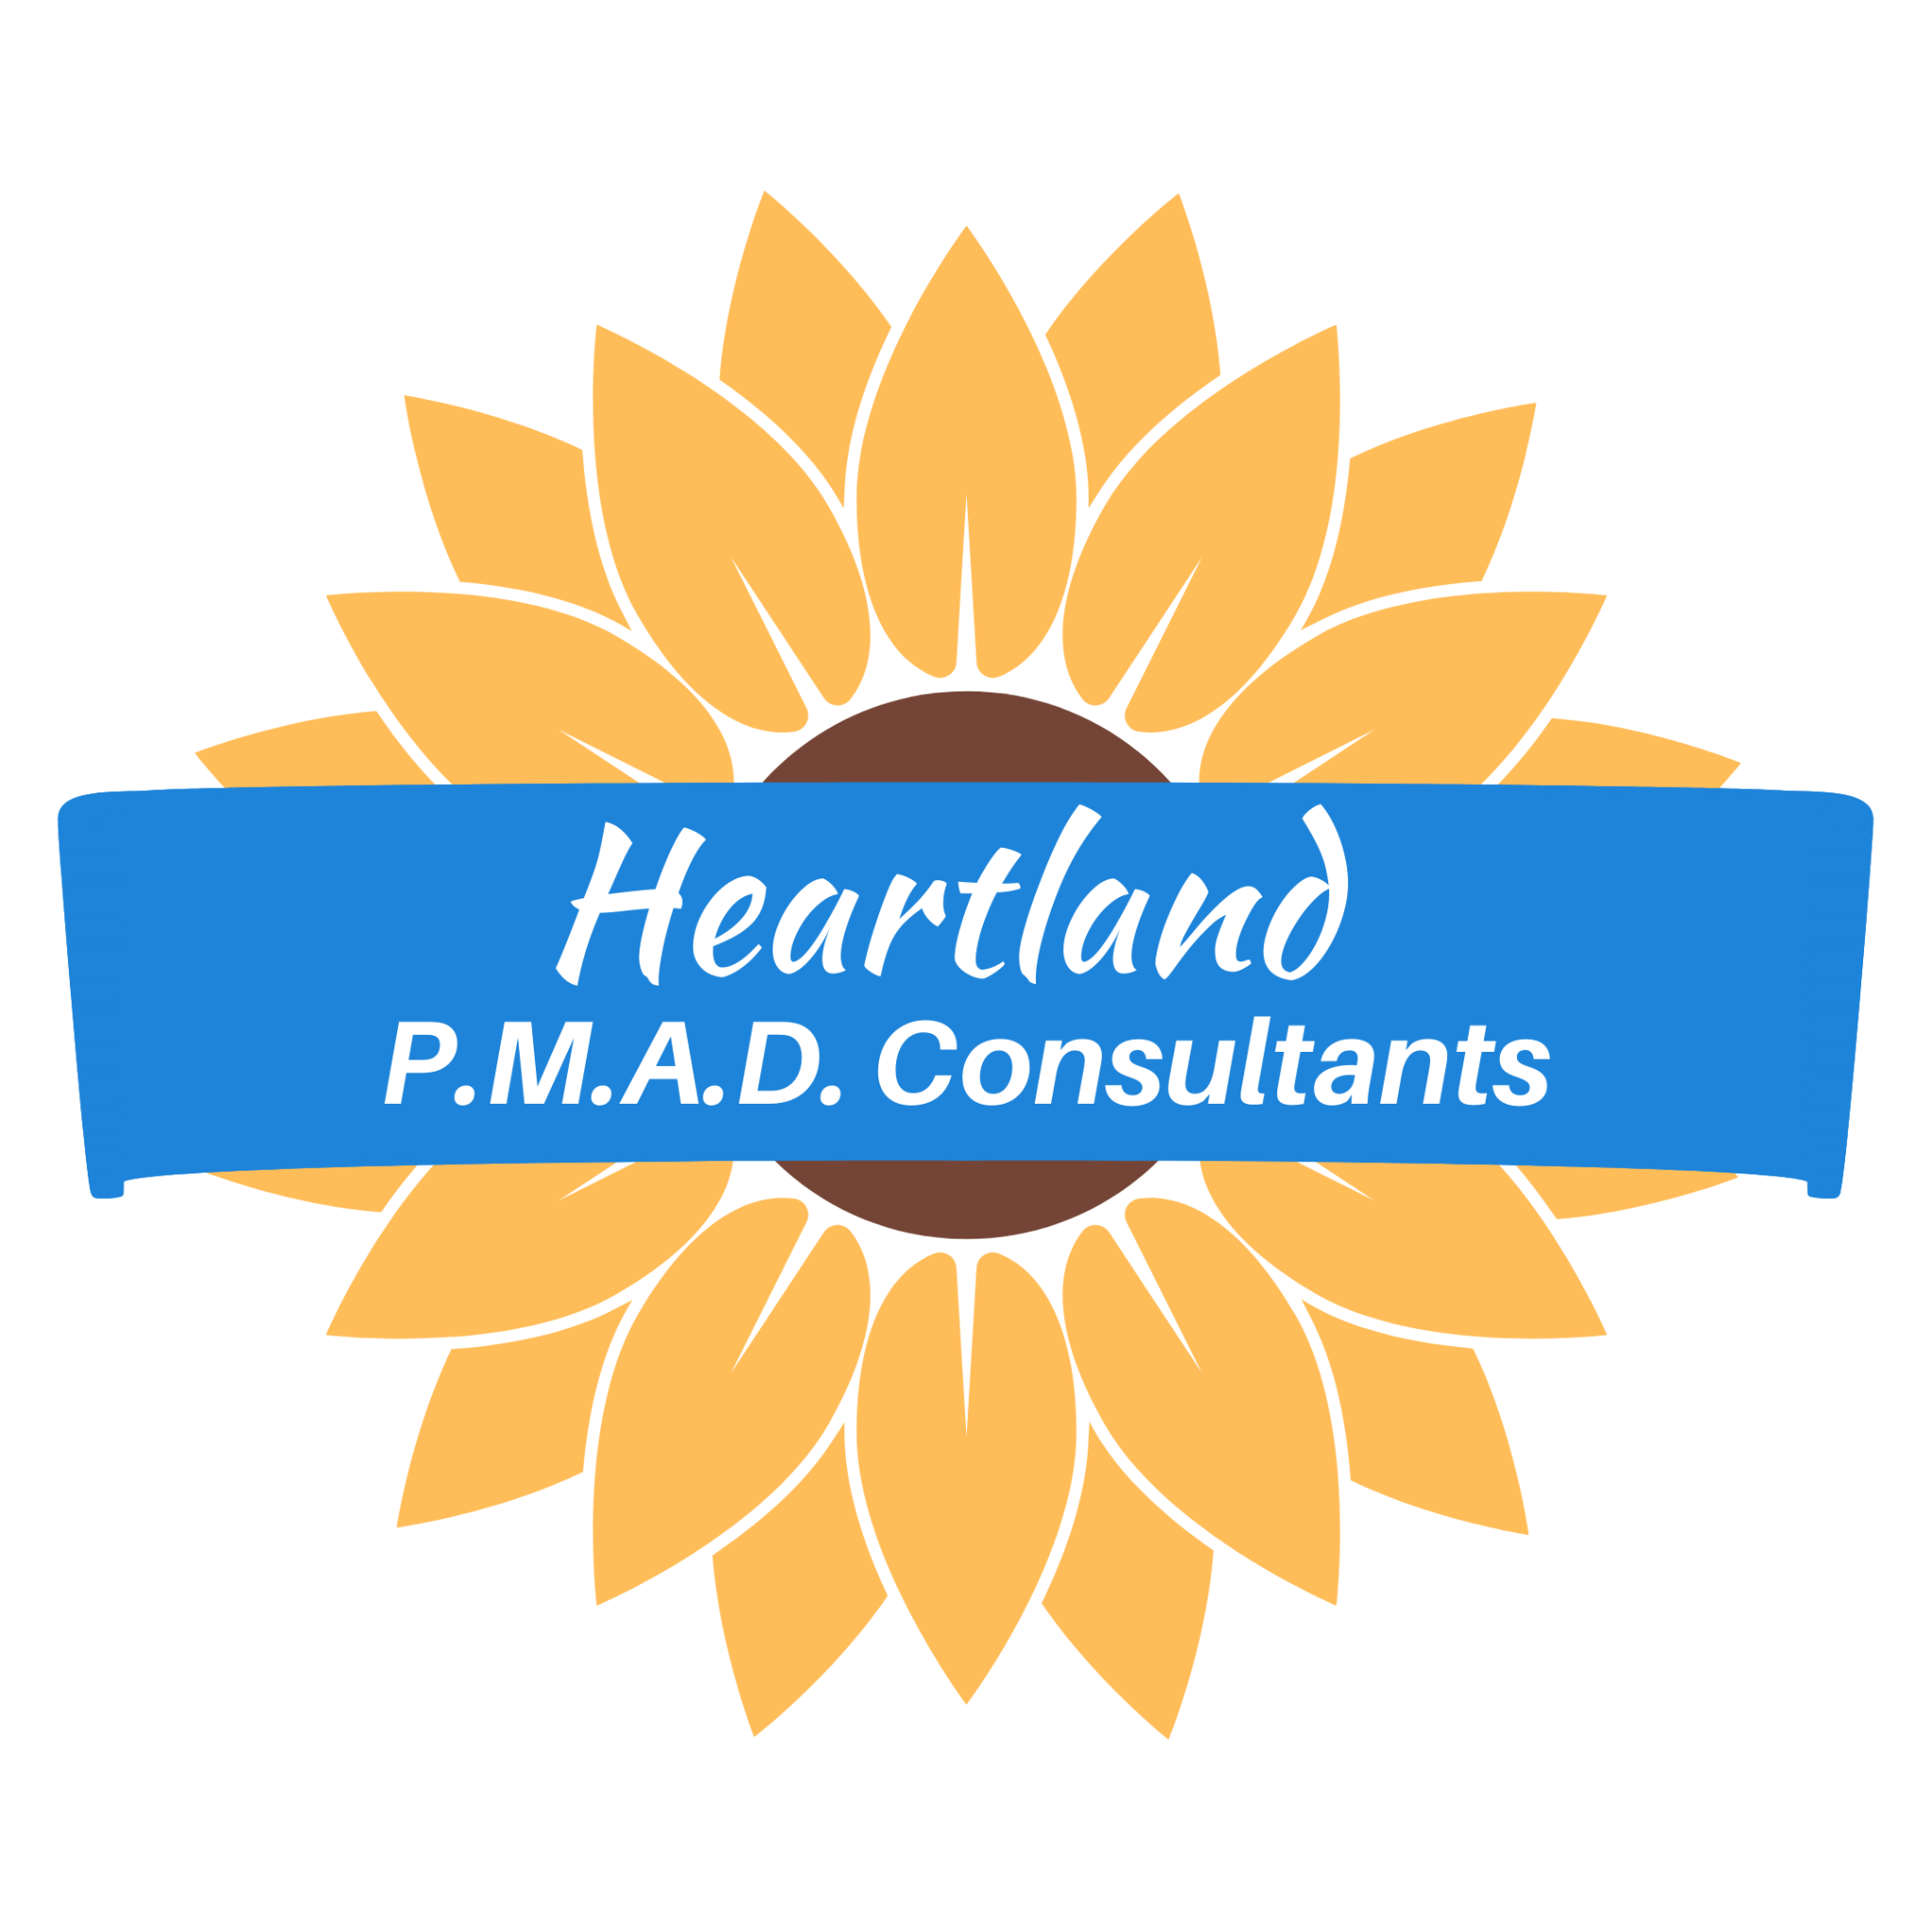

Fall 2023 Syllabus
Heartland Protocol Expert E-Course

Your Trainers:
Elizabeth Stallone-Lowder, MSW, LCSW elizabeth@heartlandpmad.com
Kim Martino-Sexton, NFC kim@heartlandpmad.com

- All weekly meetings take place on Thursdays
- All In-Person meetings occur at Delmar Divine 5501 Delmar Blvd, St. Louis, MO 63112
- All zoom meetings will use this link:
https://us02web.zoom.us/meeting/register/tZEpf-CuqjMjHNUu6zpl28hdbITm81WfximK
- All Cohort members are expected to attend all sessions. Please inform both trainers if you will be absent for a session. Attendance will be taken each week and communicated with Generate Health. If more than two (2) sessions are missed by a member, full Heartland Protocol Approved Provider status may not be granted.

# | Date | Time | Format | Content to be discussed
1 | Sep 14 | 10:00 - noon | In Person | Introduction to Trainers and E-Course
2 | Sep 21 | 10:00 - 11:00 | zoom | Overview of the Heartland Protocol: The Power of Story, PMAD Statistics, The Perinatal Life Stage,)
3 | Sep 28 | 10:00 - 11:00 | zoom | The Diagnosis, Symptoms and Causes of PMAD, Defining Matresence, Postpartum Support International (PSI
4 | Oct 5 | 10:00 - 11:00 | zoom | Compassion Fatigue & Burnout: Provider Self-care, Compassion Fatigue Professional Quality of Life Assessment,
5 | Oct 12 | 10:00 - 11:00 | zoom | Self-Compassion, Boundary Setting, Be Kinder to Yourself
6 | Oct 19 | 10:00 - 11:30 | In Person | H is for Hearing: The Essentials of Listening, A Person-Centered Approach, Listen poem
7 | Oct 26 | 10:00 - 11:00 | zoom | H is also for Holding Space: article, Acknowledgement as a Skill
8 | Nov 2 | 10:00 - 11:00 | zoom | E is for Empathy: Empathy vs. Sympathy, 4 Steps of Empathy, Everyone can Learn Empathy, featuring work from Dr. Brene Brown, Teresa Wiseman
9 | Nov 9 | 10:00 - 11:00 | zoom | E is for Empathy: Reducing the Stigma and Shame of Language, Benefits of Empathy Communication,Featuring work of Dr. Helen Reis
10 | Nov 16* | 10:00 - 11:00 | zoom | A is for Assessment: PMAD Measurements, EPDS, ACES, 20/20 Mom Screening Brief
11 | Nov 30 | 10:00 - 11:00 | zoom | A is for Assessment: Red Flags & Warning Signs DSM Doesn’t Mention
12 | Dec 7 | 10:00 - 11:30 | In Person | R is for Referral: The Power of a Warm Handoff, Radical Acceptance, You Are Not Alone - There Are Champions Everywhere, Cohort Member Agencies Featured
13 | Dec 14 | 10:00 - 11:00 | zoom | R is for Referral: Circles of Support, SWOT Analysis, Heartland Key Partners
14 | Dec 21* | 10:00 - 11:00 | zoom | T is for Touch Base:The Frequency of Touching Base, No Closed Door
15 | Jan 4, ‘24 | 10:00 - 11:00 | zoom | D. I. R. E.: Black Infant and Maternal Mortality Racism and Stress Deconstructing White Privilege Racial Justice and Equity, Deconstructing White Privilege, How Racism Affects Pregnancy
16 | Jan 11, ‘24 | 10:00 - 11:30 | zoom | Final Gathering, celebration!  Review, Synthesis and Application of The Heartland Protocol
*skip following week for holiday

